[Array 15 (2022) 100179](https://doi.org/10.1016/j.array.2022.100179)

|  |  |  |
| --- | --- | --- |
|  | Contents lists available at [ScienceDirect](http://www.elsevier.com/locate/array) |  |
| Array |
| journal homepage: [www.elsevier.com/locate/array](http://www.elsevier.com/locate/array) |
|  | | |

Classifying jobs towards power-aware HPC system operation through long-term log analysis   
Yuichi Tsujitaa,∗, Atsuya Unoa, Ryuichi Sekizawab, Keiji Yamamotoa, Fumichika Sueyasub a *RIKEN Center for Computational Science, Kobe, Hyogo, Japan*   
b *Fujitsu Limited, Tokyo, Japan*

|  |  |  |
| --- | --- | --- |
| A R T I C L E | I N F O | A B S T R A C T |
| *Keywords:*  Classification  Machine learning  Electric power  FLOPS  Memory bandwidth File I/O |  | The efficient utilization of high-performance computing (HPC) system resources under rigorous electric power budget or I/O workload constraints is among the most important goals set by system operators to deal with the demanding requirements of application users. In most cases, the effective utilization of CPU and memory devices, which is tightly linked to electric power consumption, is a counterpart metric of I/O activities in most HPC jobs. Towards higher utilization of HPC systems under strict electric power consumption and I/O activity management constrains, we must be careful to prevent hot-spots from developing in power consumption or I/O operations that could lead to unstable system operations by exceeding electric power supply or I/O subsystem capabilities. One of the feasible solutions is arranging compute node assignment not to have such hot-spots in electric power or I/O operations. To address this issue, we analyzed vast amounts of log data collected from the K computer and found strong positive correlations between CPU and memory device utilization rates and electric power consumption levels. On the one hand, we also observed strong negative correlations and reduced electric power consumption in relation to file I/O activities in a specific compute node-layout, thereby indicating unique characteristics in some I/O-intensive HPC jobs in the node-layout. Our investigation revealed that HPC jobs could be divided into two groups when classified in terms of required electric power — jobs consuming high electric power levels and I/O-intensive jobs with reduced electric power levels. Then, we achieved high levels of accuracy when classifying jobs in terms of electric power levels using RandomForestClassifier among multiple machine learning classification models provided from scikit-learn. The classification can prevent us from hot-spots in electric power consumption in compute node assignment in job scheduling. Thus we demonstrated efficient job classifications towards power-aware system operations in the supercomputer Fugaku, which is the successor to the K computer. |

**1. Introduction**

In our current era, high-performance computing (HPC) systems with huge numbers of CPU cores are now approaching exascale per-formance levels. The primary mission of HPC systems is to provide stable computing resources with high levels of utilization and usability under specific constraints such as established power consumption and I/O workload levels. However, increases in computing power require advanced storage systems of a similar scale with equally high I/O performance levels. Additionally, current and future HPC systems must accommodate wide varieties of jobs, including compute-, memory-, and I/O-intensive applications. In such situations, we have found that high utilization levels of CPU and memory devices tend to lead to high electric power consumption levels, while I/O-intensive operations tend to result in reduced electric power usage.

∗ Corresponding a[uthor.](mailto:yuichi.tsujita@riken.jp)

*E-mail address:* [yuichi.tsujita@riken.jp](mailto:yuichi.tsujita@riken.jp) (Y. Tsujita).

Our current HPC system, the supercomputer Fugaku [1] (here-inafter, Fugaku), is the successor to the K computer. Compared with the K computer, Fugaku has advanced management functions for elec-tric power consumption that ensure more stable and effective electric power usage [2,3]. Even though the K computer was decommissioned in August 2019, analyses of its power consumption during HPC job executions have already provided some useful hints for more power-aware operations using Fugaku. This is because, over its years of the K computer operation, we collected a wide variety of system logs and job stats, including performance counters related to CPU and memory devices, file I/O activities, and even environmental metrics such as system board airflow and CPU cooling water temperatures. However, since the K computer did not have any electric power measurement devices in its compute node modules, it was necessary to estimate

<https://doi.org/10.1016/j.array.2022.100179>  
[Received 15 February 2022; Accepted 25 Ap](https://doi.org/10.1016/j.array.2022.100179)ril 2022   
Available online 21 May 2022

[2590-0056](http://creativecommons.org/licenses/by-nc-nd/4.0/)/© 2022 The Author(s). Published by Elsevier Inc. This is an open access article under the CC BY-NC-ND license ([http://creativecommons.org/licenses/by-](http://creativecommons.org/licenses/by-nc-nd/4.0/)

[nc-nd/4.0/](http://creativecommons.org/licenses/by-nc-nd/4.0/)).

*Y. Tsujita et al.*  *Array 15 (2022) 100179*

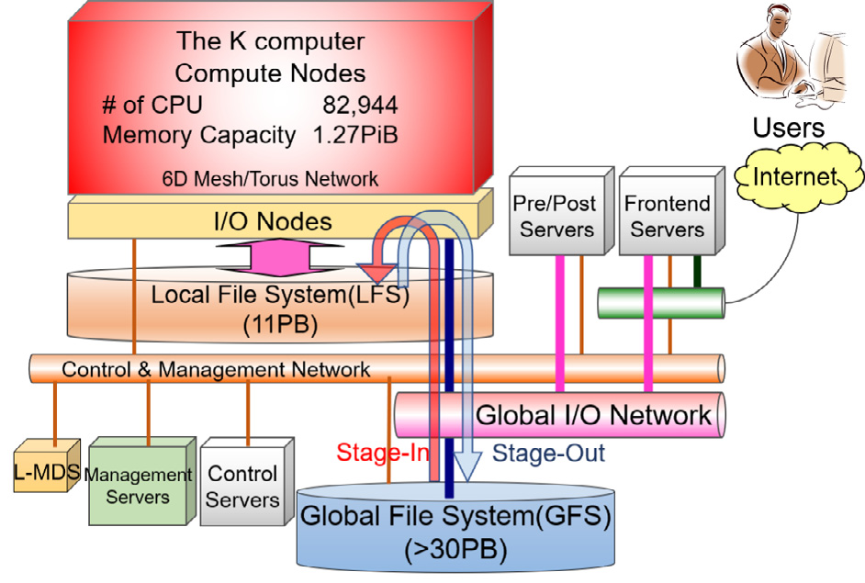

**Fig. 1.** K computer system overview.

the electric power of each compute node using the abovementioned temperature information and statistical information from our previous study [4].

Our log analyses regarding jobs executed in the K computer revealed unique correlations among CPU, memory, file I/O activities, and the compute node-layouts used. After further analysis, we determined that jobs could be split into two groups based on electric power levels— jobs requiring higher electric power levels due to high CPU and memory device utilization and jobs consuming relatively lower levels of electric power such as I/O-intensive applications. These preliminary results were reported in our conference paper [5]. Additional analyses were made by using an additional classification model to examine the usefulness of our approach. We also modified evaluation scheme for the classification models by introducing Matthews Correlation Coefficients (MCC) [6]. Furthermore, we conducted factor loading analyses of the metrics used to examine contribution rates. Our approach, which we discuss in this paper, is based on the following two-step method. First, we analyze correlation coefficients among the metrics used in job stats. Then, based on the results obtained in the first step, we perform classifications using those metrics and a machine learning (ML) scheme. The classification process leverages useful information towards more effective power-aware compute node allocation and job scheduling that is expected to be useful not only for Fugaku but for other HPC platforms as well.

The rest of this paper is organized as follows. In Section 2, we present an overview of the K computer, including the file I/O sub-systems and electric power-related metrics. Correlation analysis using job stats log is then reported in Section 3, followed by a prediction model discussion based on an ML approach in Section 4. We then discuss related work in Section 5 before finally concluding the paper and discussing our future work plans in Section 6.

**2. K computer and its electric power log collection**

*2.1. K computer overview*

After seven years of system operations, the K computer was decom-missioned in August 2019. During its operational period, vast amounts of log data on system operations, facility operations, and job stats log were collected from the K computer, and were analyzed not only for root-cause information concerning system failures or performance degradation but also by researchers searching for ways to improve system operation quality. Fig. 1 shows an overview of the K computer. The K computer consisted of 82,944 compute nodes and 5,184 I/O nodes. In operation, the compute nodes and I/O nodes were connected via high speed and low latency interconnects named Tofu [7] developed by Fujitsu. In the two-level file system that was introduced for the K

2

*Y. Tsujita et al.*  *Array 15 (2022) 100179*

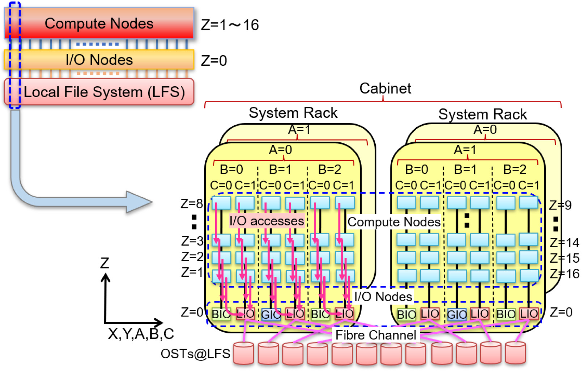

**Fig. 2.** LFS I/O subsystems with compute nodes and I/O nodes connected through Tofu interconnects.

found to be placing all the compute nodes on the same *𝑍*-link by giving 32 ( = 16 × 2) in the last dimension of the 3D node-layout in the job submission. This specification resulted in compute node layouts ranging from *𝑍* = 1 to 16 at *𝐶* = 0 and 1 with the same values in *𝐴*, *𝐵*, *𝑋*, and *𝑌* within the same cabinet.

*2.2. Electric power log collection*

As mentioned above, since the K computer did not have any electric power measurement devices, we established a prediction model [4] using the following two averaged temperature differences among the following temperature sensors:

• Temperature sensors for CPU and inlet cooling water at each compute node module (*𝛥𝑇𝐶𝑃𝑈*)  
• Temperature sensors for inlet and outlet of air-flow at each system board consisting of four compute node modules (*𝛥𝑇𝑎𝑖𝑟*)

We observed that the consumed electric power had strong correlation with *𝛥𝑇𝐶𝑃𝑈* and *𝛥𝑇𝑎𝑖𝑟*. Therefore we assumed that the electric power was proportional to the two temperature values. We obtained each coefficient as a mean value using measured data about 33,500 jobs from April 2014 to November 2014. The following formula was obtained to predict the electric power used for the K computer (*𝑃𝐾*) in our previous study [4]:

*𝑃𝐾*[MW] = 0*.*802393382361262 × *𝛥𝑇𝐶𝑃𝑈*

+ 0*.*345223838880426 × *𝛥𝑇𝑎𝑖𝑟*

+ 7*.*67202252302052

In order to evaluate correctness of the obtained formula, we made regression analysis between measured electric power and estimated one at the special rack which equipped with electric power meter for this analysis. Consequently, we confirmed that the formula achieved enough correctness through about 13,000 jobs from December 2014 to February 2015 [4].

Note that the 10 MW value referred to electric power without any computation and I/O loads, and it was included in the *𝑃𝐾* [4]. In order to characterize each job through electric power fluctuations, electric power values per compute node without the 10 MW (*𝑃𝑛𝑜𝑑𝑒*)

3

*Y. Tsujita et al.*  *Array 15 (2022) 100179*

|  |  |
| --- | --- |
| **Table 1**  List of log information collected for system operation analysis. | |
| Metric | Description |
| JOB-ID  User-ID  QUE_CLS *𝑅𝐸𝑄𝑋*  *𝑅𝐸𝑄𝑌*  *𝑅𝐸𝑄𝑍*  *𝑁𝐷𝑋*  *𝑁𝐷𝑌*  *𝑁𝐷𝑍*  *𝑇𝑙𝑖𝑚𝑖𝑡 𝑒𝑙𝑎𝑝𝑠𝑒*  *𝑇𝑒𝑙𝑎𝑝𝑠𝑒*  *𝑁𝑄*  *𝑆𝐼*∕*𝑂*  *𝑅𝐹*  *𝑅𝑀*  *𝑃𝑚𝑎𝑥 𝑛𝑜𝑑𝑒*  *𝑃𝑚𝑖𝑛 𝑛𝑜𝑑𝑒*  *𝑃𝑚𝑒𝑎𝑛 𝑛𝑜𝑑𝑒* | Unique JOB-ID given for each job  User-ID of the submitted job  Queue class used for the job  Requested number of compute nodes in Tofu *𝑋*-link direction Requested number of compute nodes in Tofu *𝑌* -link direction Requested number of compute nodes in Tofu *𝑍*-link direction Allocated number of compute nodes in Tofu *𝑋*-link direction Allocated number of compute nodes in Tofu *𝑌* -link direction Allocated number of compute nodes in Tofu *𝑍*-link direction Elapsed time limit for the job  Elapsed time of the executed job  The allocated disk space per compute node specified  by *node-quota* option  Total bytes of file I/O  The ratio of sustained FLOPS relative to the peak FLOPS The ratio of sustained memory bandwidth utilization  relative to the theoretical bandwidth  The maximum value of *𝑃𝑛𝑜𝑑𝑒*  The minimum value of *𝑃𝑛𝑜𝑑𝑒*  The mean value of *𝑃𝑛𝑜𝑑𝑒* |

In our search for answers, using job stats log data from the second half term of 2016 to the first half term of 2018 of the Japanese fiscal year, we selected the following metrics for each job that ran equal to or more than 10 min without any errors in the largest queue class named‘‘large’’. There were two reasons for using log data during this two-year term; the second half term of 2016 was chosen as the start time because of also marked the establishment of the abovementioned electric power prediction process using temperature log data, while the first half term of 2018 was selected as the end time because we began conducting cooling system examinations (in which cooling water temperatures were intentionally changed) from the second term of 2018. This meant we could not use the estimation model to predict electric power during that period.

The following metrics were used from the log data:

• *𝑁𝑄*: The allocated disk space per node by *node-quota*  
• *𝑁𝐷𝑍*: The number of allocated compute nodes in Tofu *𝑍*-link direction  
• *𝑅𝐷*: The ratio of used disk space relative to the assigned disk space specified by the *node-quota* option  
• *𝑅𝐼*∕*𝑂*: The ratio of used disk space relative to the maximum achievable amount of I/O size  
• *𝑅𝐹* : The ratio of sustained FLOPS relative to the peak FLOPS• *𝑅𝑀*: The ratio of sustained memory bandwidth utilization relative to the theoretical bandwidth

• *𝑃𝑚𝑎𝑥 𝑛𝑜𝑑𝑒*: The maximum electric power per compute node in situa- tions where the electric power basement has been removed

Note that the ‘‘large’’ queue class covered about 90% of the K computer compute nodes and accepted jobs using from 385 to 36,864 compute nodes. Hereinafter, we describe jobs executed in this queue class as large jobs.

While four of the abovementioned metrics are related to file I/O activities, the rest are related to electric power. The two file I/O-related metrics, *𝑅𝐷* and *𝑅𝐼*∕*𝑂*, are clarified as follows:

*𝐷𝐼*∕*𝑂* = *𝑆𝐼*∕*𝑂*∕*𝑁𝐷𝑋*∕*𝑁𝐷𝑌* ∕*𝑁𝐷𝑍*

*𝑅𝐷* = *𝐷𝐼*∕*𝑂*∕*𝑁𝑄*

*𝑅𝐼*∕*𝑂* = *𝐷𝐼*∕*𝑂*∕*𝑚𝑖𝑛*(*𝑁𝑄, 𝐵𝑊𝑚𝑎𝑥 𝐼*∕*𝑂*× *𝑇 𝑙𝑖𝑚𝑖𝑡 𝑒𝑙𝑎𝑝𝑠𝑒*)

*𝐷𝐼*∕*𝑂*, *𝐵𝑊𝑚𝑎𝑥 𝐼*∕*𝑂*, and *𝑇 𝑙𝑖𝑚𝑖𝑡 𝑒𝑙𝑎𝑝𝑠𝑒*are the actual file I/O size per node, max-imum I/O bandwidth, and elapsed time limit, respectively. Note that

*𝐵𝑊𝑚𝑎𝑥 𝐼*∕*𝑂*× *𝑇 𝑙𝑖𝑚𝑖𝑡 𝑒𝑙𝑎𝑝𝑠𝑒*is an achievable maximum I/O size amount if a job utilizes 100% of the I/O bandwidth and is within the elapsed time

4

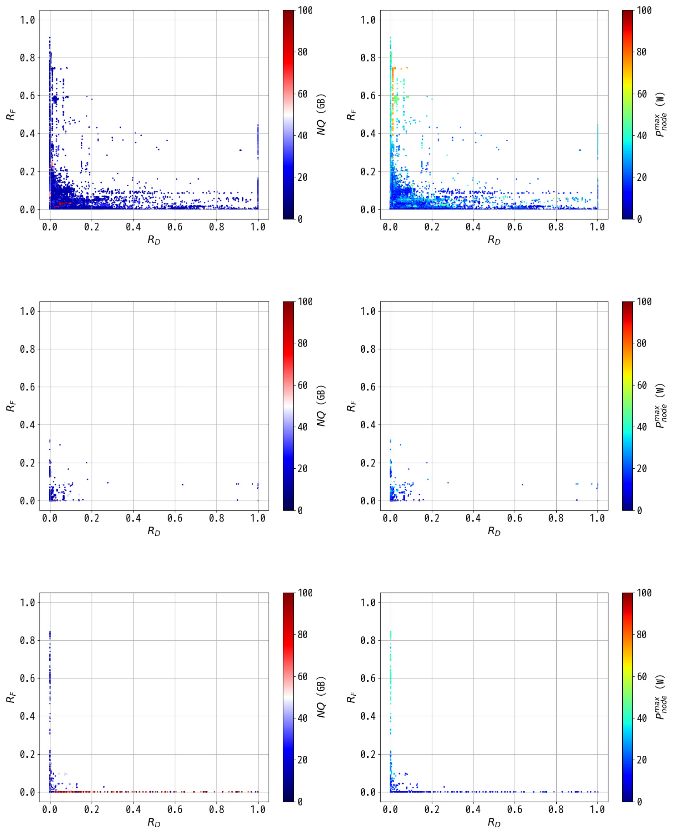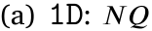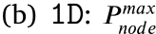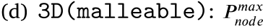

|  |  |  |  |
| --- | --- | --- | --- |
| *Y. Tsujita et al.* |  |  | *Array 15 (2022) 100179* |

|  |  |
| --- | --- |
| **Fig. 3.** Correlation between *𝑅𝐷* and *𝑅𝐹* with indicating *𝑁𝑄* and *𝑃𝑚𝑎𝑥 𝑛𝑜𝑑𝑒*in each color-bar about jobs in the three node-layout cases, 1D, 3D(malleable), and 3D(same).  interpretation of the references to color in this figure legend, the reader is referred to the web version of this article.) | (For |

*3.2. Correlation between 𝑅𝐷 and 𝑅𝑀*

Since memory bandwidth utilization is another key metric that tightly corresponds to electric power, we examined correlation between *𝑅𝐷* and *𝑅𝑀* using colored plots describing *𝑁𝑄* and *𝑃𝑚𝑎𝑥 𝑛𝑜𝑑𝑒*, as shown in Fig. 4.

The correlation between *𝑅𝐷* and *𝑅𝐹* shows similar behavior. Con-cerning the 1D jobs shown in Figs. 4(a) and 4(b), we can see that jobs with lower *𝑅𝐷* tend to achieve higher ratios in *𝑅𝑀*, and that such higher *𝑅𝑀* leads to higher *𝑃𝑚𝑎𝑥 𝑛𝑜𝑑𝑒*. It is also noted that we could separate the 1D jobs into three groups about the *𝑃𝑚𝑎𝑥 𝑛𝑜𝑑𝑒*along *𝑅𝑀*, as shown in

5

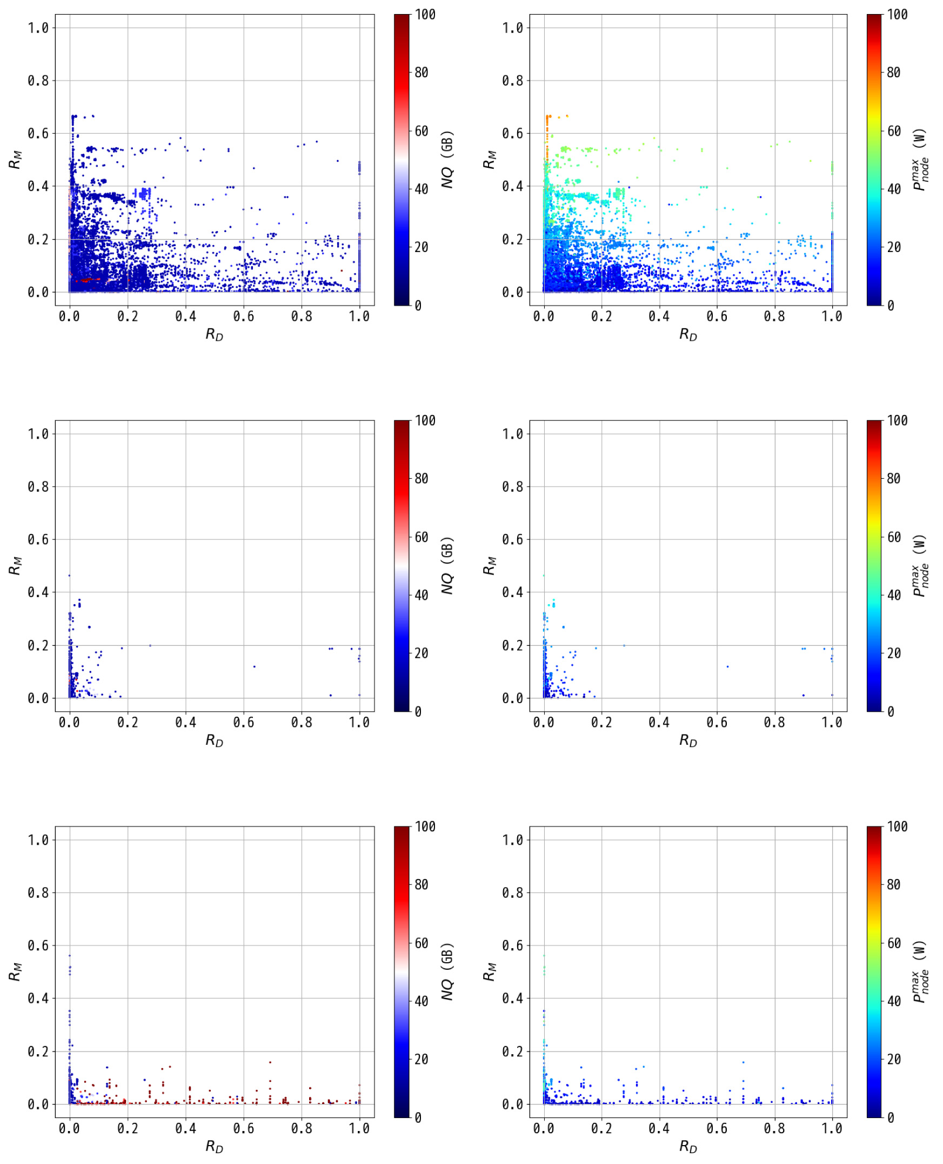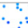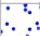

|  |  |  |  |
| --- | --- | --- | --- |
| *Y. Tsujita et al.* |  |  | *Array 15 (2022) 100179* |

**Fig. 4.** Correlation between *𝑅𝐷* and *𝑅𝑀* with *𝑁𝑄* and *𝑃𝑚𝑎𝑥 𝑛𝑜𝑑𝑒*in each color-bar providing indications about jobs in the three node-layout cases, 1D, 3D(malleable), and 3D(same). (For interpretation of the references to color in this figure legend, the reader is referred to the web version of this article.)

*3.3. Correlation between 𝑅𝑀 and 𝑅𝐹*

As described previously, the major sources of electric power con-sumption by compute nodes are CPU and memory devices, which means that compute- or memory-intensive HPC jobs tend to consume higher levels of electric power. We examined correlation between *𝑅𝑀* and *𝑅𝐹* with colored plots that indicate *𝑁𝑄* and *𝑃𝑚𝑎𝑥 𝑛𝑜𝑑𝑒*.

Fig. 5 shows the correlations between *𝑅𝑀* and *𝑅𝐹* of each job in 1D, *𝑛𝑜𝑑𝑒*   
3D(malleable), and 3D(same) job cases with the *𝑁𝑄* and *𝑃𝑚𝑎𝑥* shown in colored plots.

6

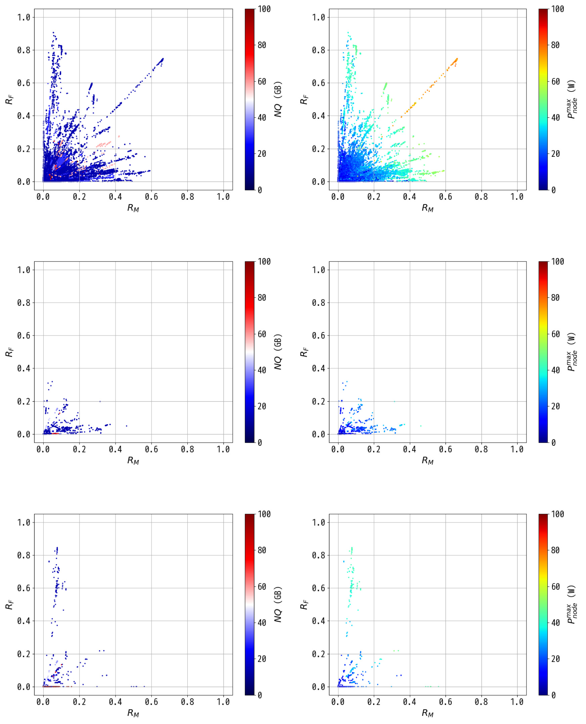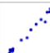

|  |  |  |  |
| --- | --- | --- | --- |
| *Y. Tsujita et al.* |  |  | *Array 15 (2022) 100179* |

|  |  |
| --- | --- |
| **Fig. 5.** Correlation between *𝑅𝑀* and *𝑅𝐹* with *𝑁𝑄* and *𝑃𝑚𝑎𝑥 𝑛𝑜𝑑𝑒*shown in each color-bar for jobs in the three node-layout cases, 1D, 3D(malleable), and 3D(same).  interpretation of the references to color in this figure legend, the reader is referred to the web version of this article.) | (For |

When compared with the 1D jobs, the number of 3D jobs was smaller, and the 3D job situations were different from the 1D jobs. The figures in this group indicate lower utilization in both *𝑅𝑀* and *𝑅𝐹* . Jobs with *𝑁𝑄* values higher than 50 GB/node were observed with lower values in the range from 0 to 0.2 in *𝑅𝑀* and *𝑅𝐹* , as shown in Fig. 5(c). Fig. 5(d) shows us that most of the jobs consumed relatively lower electric power and that jobs with relatively high electric power around 40 W had low *𝑁𝑄*, as shown in Fig. 5(c).

On the other hand, the 3D(same) job situation showed differences from the 3D(malleable) job situation, and it was seen that there are jobs with higher *𝑅𝐹* that have linear relationships with *𝑅𝑀*. In Fig. 5(e),

7

*Y. Tsujita et al.*  *Array 15 (2022) 100179*

|  |  |  |  |  |  |  |  |
| --- | --- | --- | --- | --- | --- | --- | --- |
| **Table 2**  Correlation coefficients (upper) and p-values (lower) between each metric used (*𝑁𝑄*,  *𝑁𝐷𝑍*, *𝑅𝐷*, *𝑅𝐼*∕*𝑂*, *𝑅𝐹* , and *𝑅𝑀*) and *𝑃𝑚𝑎𝑥 𝑛𝑜𝑑𝑒*.  Node-layout Metric Used correlation functions | | | | | | | |
| (# Jobs) | | | | Pearson(Log) | | Spearman | Kendall |
| *𝑁𝑄* | | | | 0.146  (*𝑝 <* 0*.*001) | | 0.203  (*𝑝 <* 0*.*001) | 0.161  (*𝑝 <* 0*.*001) |
| *𝑁𝐷𝑍* | | | | | −0.0158  (*𝑝 <* 0*.*001) | 0.0116  (*𝑝 <* 0*.*001) | 0.00704  (*𝑝 <* 0*.*001) |
| 1D  (127,439) | *𝑅𝐷* | | | −0.187  (*𝑝 <* 0*.*001) | | −0.123  (*𝑝 <* 0*.*001) | −0.0760  (*𝑝 <* 0*.*001) |
| *𝑅𝐼*∕*𝑂* | | | | −0.181  (*𝑝 <* 0*.*001) | | −0.123  (*𝑝 <* 0*.*001) | −0.0760  (*𝑝 <* 0*.*001) |
| *𝑅𝐹* | | | | 0.649  (*𝑝 <* 0*.*001) | | 0.693  (*𝑝 <* 0*.*001) | 0.499  (*𝑝 <* 0*.*001) |
| *𝑅𝑀* | | | | 0.749  (*𝑝 <* 0*.*001) | | 0.756  (*𝑝 <* 0*.*001) | 0.565  (*𝑝 <* 0*.*001) |
| *𝑁𝑄* | | | | 0.0266  (*𝑝 <* 1) | | 0.0901  (*𝑝 <* 0*.*001) | 0.0722  (*𝑝 <* 0*.*001) |
| *𝑁𝐷𝑍* | | | | | 0.0455  (*𝑝 <* 0*.*1) | 0.239  (*𝑝 <* 0*.*001) | 0.182  (*𝑝 <* 0*.*001) |
| 3D(malleable) (1,512) | | | *𝑅𝐷* | −0.0247  (*𝑝 <* 1) | | −0.0784  (*𝑝 <* 0*.*01) | −0.0505  (*𝑝 <* 0*.*01) |
| *𝑅𝐼*∕*𝑂* | | | | −0.0254  (*𝑝 <* 1) | | −0.0785  (*𝑝 <* 0*.*01) | −0.0505  (*𝑝 <* 0*.*01) |
| *𝑅𝐹* | | | | 0.613  (*𝑝 <* 0*.*001) | | 0.662  (*𝑝 <* 0*.*001) | 0.459  (*𝑝 <* 0*.*001) |
| *𝑅𝑀* | | | | 0.770  (*𝑝 <* 0*.*001) | | 0.773  (*𝑝 <* 0*.*001) | 0.571  (*𝑝 <* 0*.*001) |
| *𝑁𝑄* | | | | −0.460  (*𝑝 <* 0*.*001) | | −0.408  (*𝑝 <* 0*.*001) | −0.320  (*𝑝 <* 0*.*001) |
| *𝑁𝐷𝑍* | | | | | −0.620  (*𝑝 <* 0*.*001) | −0.701  (*𝑝 <* 0*.*001) | −0.561  (*𝑝 <* 0*.*001) |
| 3D(same) (985) | | *𝑅𝐷* | | −0.500  (*𝑝 <* 0*.*001) | | −0.433  (*𝑝 <* 0*.*001) | −0.282  (*𝑝 <* 0*.*001) |
| *𝑅𝐼*∕*𝑂* | | | | −0.501  (*𝑝 <* 0*.*001) | | −0.434  (*𝑝 <* 0*.*001) | −0.282  (*𝑝 <* 0*.*001) |
| *𝑅𝐹* | | | | 0.745  (*𝑝 <* 0*.*001) | | 0.693  (*𝑝 <* 0*.*001) | 0.505  (*𝑝 <* 0*.*001) |
| *𝑅𝑀* | | | | 0.722  (*𝑝 <* 0*.*001) | | 0.736  (*𝑝 <* 0*.*001) | 0.520  (*𝑝 <* 0*.*001) |
| node-layout case. In this examination, to ensure equal log data infor-mation in each metric combination, we excluded log data that were missing any of the metrics. The results obtained in the cases of 1D, 3D(malleable), and 3D(same) are summarized in Table 2. In Table 2, strong or relatively strong positive correlation coeffi-cients can be observed about *𝑅𝐹* and *𝑅𝑀* with *𝑃𝑚𝑎𝑥 𝑛𝑜𝑑𝑒*in every node-layout case because high utilization levels in memory devices or CPUs lead to high electric power levels. Among the three node-layout cases, 3D(malleable) shows very weak correlation coefficients for the metrics associated with file I/O (*𝑁𝑄*, *𝑁𝐷𝑍*, *𝑅𝐷*, and *𝑅𝐼*∕*𝑂*) with *𝑃𝑚𝑎𝑥 𝑛𝑜𝑑𝑒* compared with those in the other node-layout cases.  Another significant point is the relatively strong negative correla-tion coefficients observed in *𝑁𝑄*, *𝑁𝐷𝑍*, and *𝑅𝐷* of the 3D(same) case. This is due to the I/O-intensive jobs observed at high frequency in this node-layout case. This kind of jobs explicitly specified the fixed compute node-layout due to its suitability for I/O operations. In such jobs, higher disk space was given in *𝑁𝑄*, and a higher value in *𝑅𝐷* was observed. Additionally, unlike the other node-layout cases, those jobs tended to use all the compute nodes in the Tofu *𝑍*-link. | | | | | | | |

**4. Job classification using machine learning**

Large-scale HPC systems such as Fugaku must accept inflexible restrictions in terms of electric power management in order to ensure

8

*Y. Tsujita et al.*  *Array 15 (2022) 100179*

*4.2. Job classification using imbalanced datasets*

Based on the cumulative distributed function shown in Fig. 6, we further examined electric power classifications for improved com-pute node assignments in terms of electric power using an ML ap-proach, where the following four classification models provided in *scikit-learn*[18] Python library were examined:

• LogisticRegression (hereinafter, LOR)  
• DecisionTreeClassifier (hereinafter, DTC)• RandomForestClassifier (hereinafter, RFC)• KNeighborsClassifier (hereinafter, KNC)

We used job stats log data recorded in the same period as those used in the correlation coefficient examinations. More specifically, we examined the four prediction models for the *𝑃𝑚𝑎𝑥 𝑛𝑜𝑑𝑒*using several metrics combinations such as *𝑅𝑀*, *𝑅𝐹* , and *𝑅𝐷* with the help of the correlation coefficient analyses reported in Section 3. Training and testing datasets were prepared using train_test_split() from major group data consisting of job information with lower electric power levels (X) and minor group data consisting of job information with higher electric power levels (y), which were obtained by splitting the log data infor-mation at the given electric power threshold. The dataset preparation was performed by

X_train, X_test, y_train, y_test

= train_test_split(X, y, random_state=42,

test_size=0.25, stratify=y)

X_train and y_train are training datasets for jobs with lower and higher electric power levels, respectively, while X_test and y_test are testing datasets for jobs with lower and higher electric power levels, respectively. Note that since the stratify specification implies the same y distribution characteristics for both training and testing, we used the same datasets every time we performed examinations with the same distribution characteristics. It should be also noted that 75% of the data were assigned to the training dataset, and the remainder were assigned to the testing dataset.

The large jobs can be divided into two groups easily, one in which the *𝑃𝑚𝑎𝑥 𝑛𝑜𝑑𝑒*is greater or equal to 60 W and another in which the *𝑃 𝑚𝑎𝑥* is less than 60 W, as can be seen in Fig. 6. Note that only the 1D job case includes jobs that exceed 60 W in the *𝑃𝑚𝑎𝑥 𝑛𝑜𝑑𝑒*. We consider 30 W as *𝑛𝑜𝑑𝑒*because *𝑃𝑙𝑜𝑤* jobs are below an another threshold candidate in the *𝑃𝑚𝑎𝑥*   
or equal to 30 W in Fig. 6. It is noted that setting 30 W for the threshold in *𝑃𝑚𝑎𝑥 𝑛𝑜𝑑𝑒*leads to a mixed situation because each job case consists of jobs that exceed 30 W in the *𝑃𝑚𝑎𝑥 𝑛𝑜𝑑𝑒*. We analyzed the classification models in terms of *𝑃𝑚𝑎𝑥 𝑛𝑜𝑑𝑒*by setting 60 W and 30 W in the classification threshold. In both threshold cases, we compared the precision of the models in the three job cases (1D, 3D(malleable), and 3D(same)) and the job case consisting of the three job cases (hereinafter, All) to examine electric-power-aware compute node allocation in the supercomputer Fugaku which is the successor to the K computer. Table 3 shows the number of jobs assigned for the testing dataset.

Since the two job cases, ‘‘3D(malleable)’’ and ‘‘3D(same)’’, did not have jobs above 50 W, we excluded those node layout cases from the examination when classifying jobs at the threshold levels of 60 W and 50 W, even though both node layout cases had jobs below the threshold levels. The dataset that was split at 40 W did not have jobs to be analyzed at the ‘‘3D(malleable)’’ layout due to the same reason. In the four classification models, we utilized GridSearchCV() [19] to find the optimal parameter-set for each model, and then used that set for classification. The argument parameters are summarized in Table 4.

To improve analysis performance, the number of threads available at a PC server was set for the *num_thread* to improve analysis perfor-mance. The GridSearchCV() provides the best parameters from the set of parameter candidates given in the *param_grid*.

9

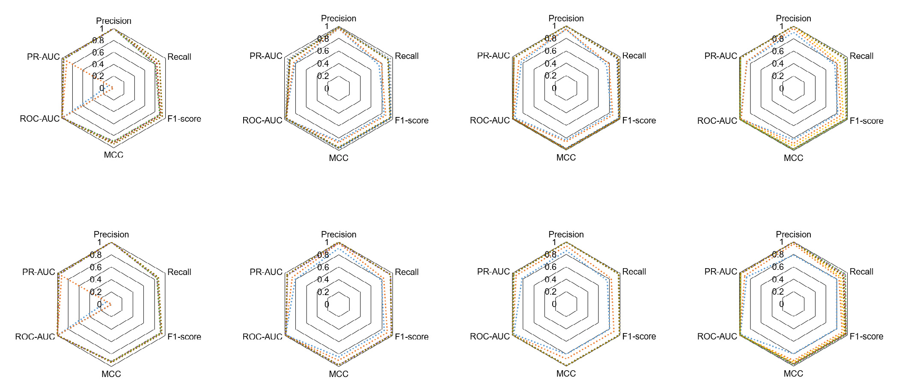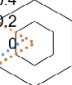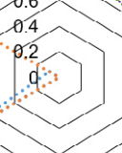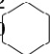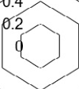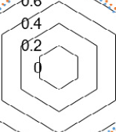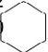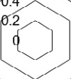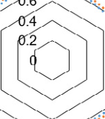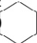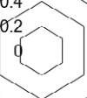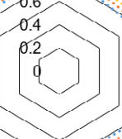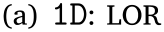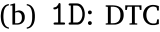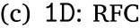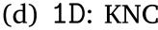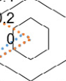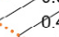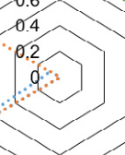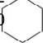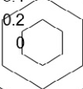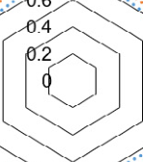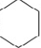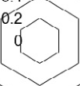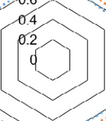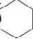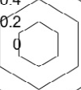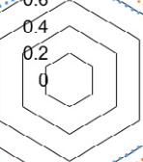

*Y. Tsujita et al.*  *Array 15 (2022) 100179*

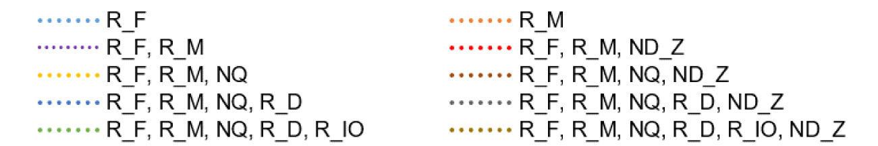

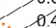

|  |  |  |  |
| --- | --- | --- | --- |
|  |  |  |  |

**Fig. 7.** Scores of predicted classification models with the threshold set at 60 W in the *𝑃𝑚𝑎𝑥 𝑛𝑜𝑑𝑒*.

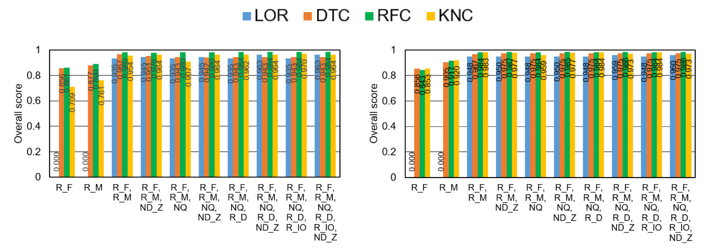

 

**Fig. 8.** Overall scores of the classification models with the threshold set at 60 W in the *𝑃𝑚𝑎𝑥 𝑛𝑜𝑑𝑒*, where numbers in the graph represent each overall score.

*𝑅𝑀* as shown in Figs. 7(b), 7(c), and 7(d), respectively. The MCC value of the LOR model is around 0.9 with *𝑅𝐹* and *𝑅𝑀*. However, since this model cannot achieve a score that is comparable to other models, as shown in Fig. 7(a), it cannot be used in the LOR model with fewer metrics from the evaluation.

Although the All case consists of the 3D(malleable) and 3D(same) jobs below 60 W, almost the same situation is observed in the evaluated models, as shown in Figs. 7(e), 7(f), 7(g), and 7(h). This is because of the smaller number of jobs (32,413–31,789 = 624 from Table 3) in the testing datasets for both 3D(malleable) and 3D(same).

The overall scores of the classification models in terms of the metrics used are summarized in Fig. 8.

In the overall 1D scores shown in Fig. 8(a), the RFC model achieved the highest score (0.98) for the evaluated models with only *𝑅𝐹* and *𝑅𝑀*. The RFC model also slightly improved scores up to 0.984 by incorporating other metrics such as *𝑅𝐷* or *𝑅𝐼*∕*𝑂* and showed similar

10

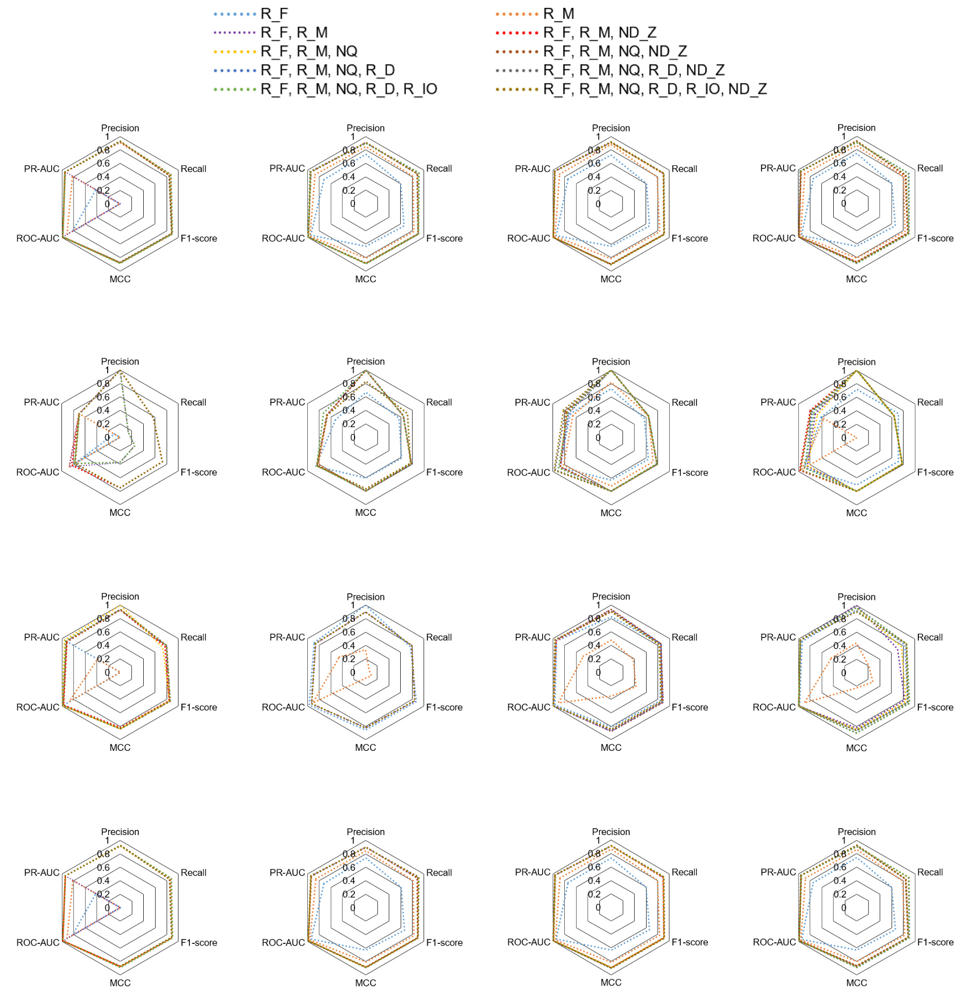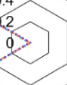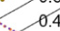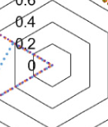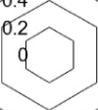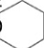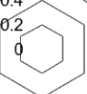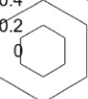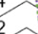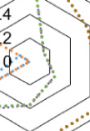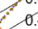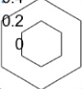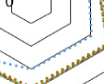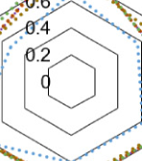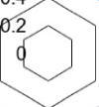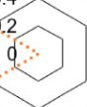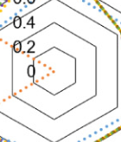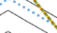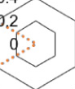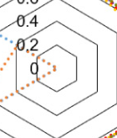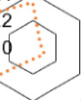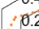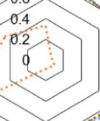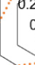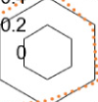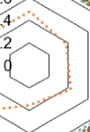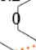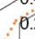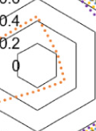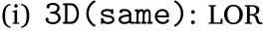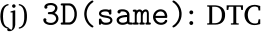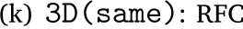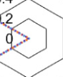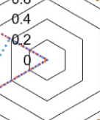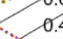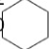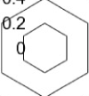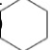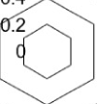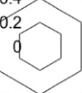

|  |  |  |  |  |
| --- | --- | --- | --- | --- |
| *Y. Tsujita et al.* |  |  |  | *Array 15 (2022) 100179* |
|  |

**Fig. 9.** Scores of predicted classification models with the threshold set at 30 W in the *𝑃𝑚𝑎𝑥 𝑛𝑜𝑑𝑒*.

improve scores to levels equal to or exceeding 0.8 in F1-score, MCC, and PR-AUC.

Based on the evaluated scores in F1-score, MCC, and PR-AUC, we summarized the overall scores of the predicted classification models in Fig. 10.

The RFC achieved the highest values of about 0.945, 0.832, and 0.944 in the cases of 1D, 3D(malleable), and All, respectively. In the 3D(same) case, the KNC achieved the highest score of 0.942 but the RFC achieved a comparable score of 0.929. In [24], the authors reported that the RFC model performed well when used to classify a large imbalanced dataset and we achieved a similar result with our imbalanced dataset.

11

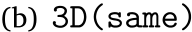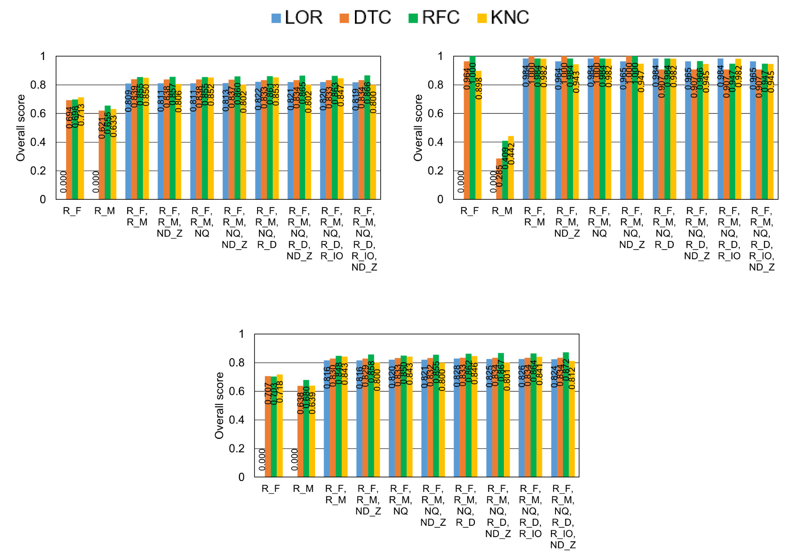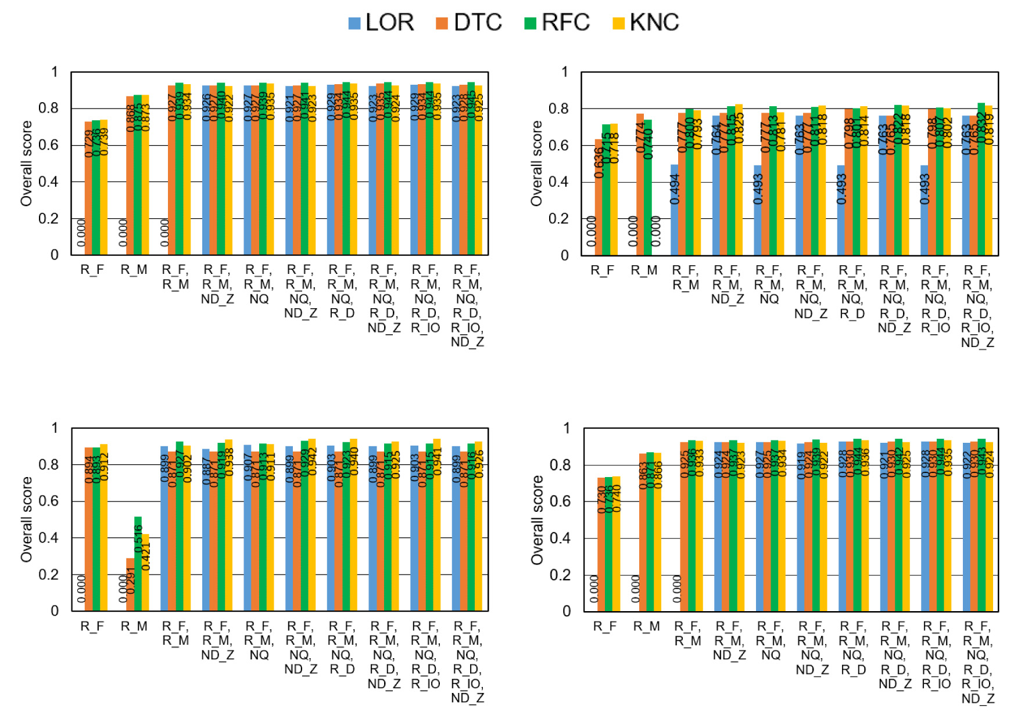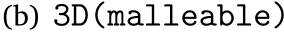

|  |  |  |  |
| --- | --- | --- | --- |
| *Y. Tsujita et al.* |  |  | *Array 15 (2022) 100179* |

**Fig. 10.** Overall scores of the four classification models with the threshold set at 30 W in the *𝑃𝑚𝑎𝑥 𝑛𝑜𝑑𝑒*, where the numbers in the graph represent each overall score.



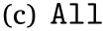

**Fig. 11.** Overall scores of the four classification models with the threshold set at 40 W in the *𝑃𝑚𝑎𝑥 𝑛𝑜𝑑𝑒*, where the numbers in the graph represent each overall score.

12

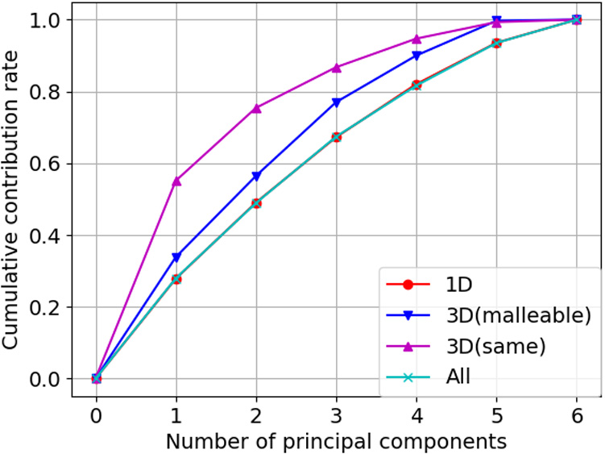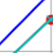

*Y. Tsujita et al.*  *Array 15 (2022) 100179*

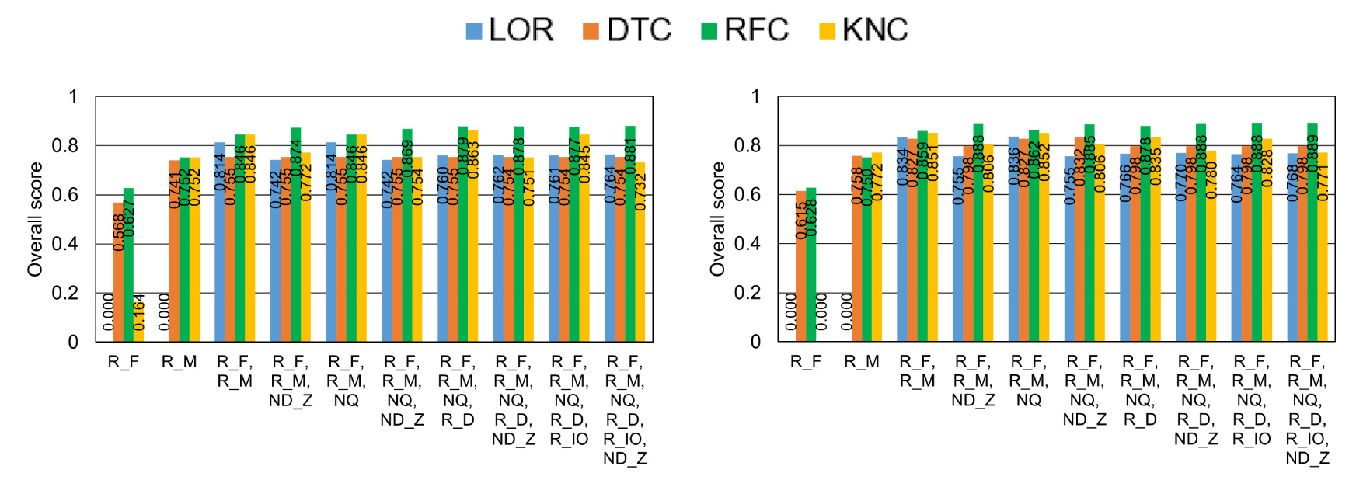

 

**Fig. 12.** Overall scores of the four classification models with the threshold set at 50 W in the *𝑃𝑚𝑎𝑥 𝑛𝑜𝑑𝑒*, where the numbers in the graph represent each overall score.

executed in the 1D case, similar behaviors for all six metrics used were   
observed in the All case.

The behavior of two file I/O-related metrics, *𝑁𝑄* and *𝑁𝐷𝑍*, are   
noteworthy because they showed different properties in each node-  
layout. In the cases of 1D, 3D(malleable), All shown in Figs. 14(a),   
14(b), and 14(d), the contribution rates of *𝑁𝑄* and *𝑁𝐷𝑍* to PC2 were   
larger than those to PC1, while their contribution rates to PC1 increased   
in the case of 3D(same), as shown in Fig. 14(c). This is because of the   
I/O-intensive jobs that specified higher values in *𝑁𝑄* and which, to the   
maximum extent possible, had compute nodes in the same Tofu *𝑍*-link   
of the 3D(same) node-layout.

From the above analysis in addition to correlation coefficients re-  
ported in Table 2, we can state the following:

**Fig. 13.** Cumulative contribution rate of principal components in each node-layout case.

3D(same) jobs had two distinct groups: one group consisted of I/O-intensive jobs, while other had compute-intensive jobs. As a result, we have achieved higher scores only in the 3D(same) jobs.

*4.3. Factor loading of metrics in the job classification*

In order to examine the contribution rate of the principal com-ponents and the factor loading of the metrics used in the princi-pal components, we performed principal component analysis using sklearn.decomposition.PCA() in *scikit-learn* after standardiz-ing each metric. Fig. 13 shows cumulative contribution rate relative to the number of principal components ranging from the most influential principal component to the least influential one. This figure shows that we can achieve higher HPC job classification levels of precision in the cases of 3D(malleable) and 3D(same) than can be achieved for the All case, which means that when performing job classification, it is better to split the HPC jobs in each node-layout.

Fig. 14 indicates the factor loading of each metric relative to the two major principal components, PC1 and PC2, in each node-layout. In Figs. 14(a), 14(b), and 14(d), it can be seen that two file I/O-related metrics, *𝑅𝐷* and *𝑅𝐼*∕*𝑂*, are related to the first principal compo-nent, PC1, at around 0.75 relative to the second principal component, PC2, while Fig. 14(c) shows that the two metrics are related to both of PC1 and PC2 around 0.5.

The computing related metrics, *𝑅𝐹* and *𝑅𝑀*, showed similar be-havior expressing a higher contribution of *𝑅𝐹* to PC2, as shown in Figs. 14(a) and 14(d), while Figs. 14(b) and 14(c) show different behavior in each case. When compared with *𝑅𝐹* , it can be seen that *𝑅𝑀* has a smaller contribution to both PC1 and PC2 in the cases of 1D and All, as shown in Figs. 14(a) and 14(d). Since most HPC jobs were

13

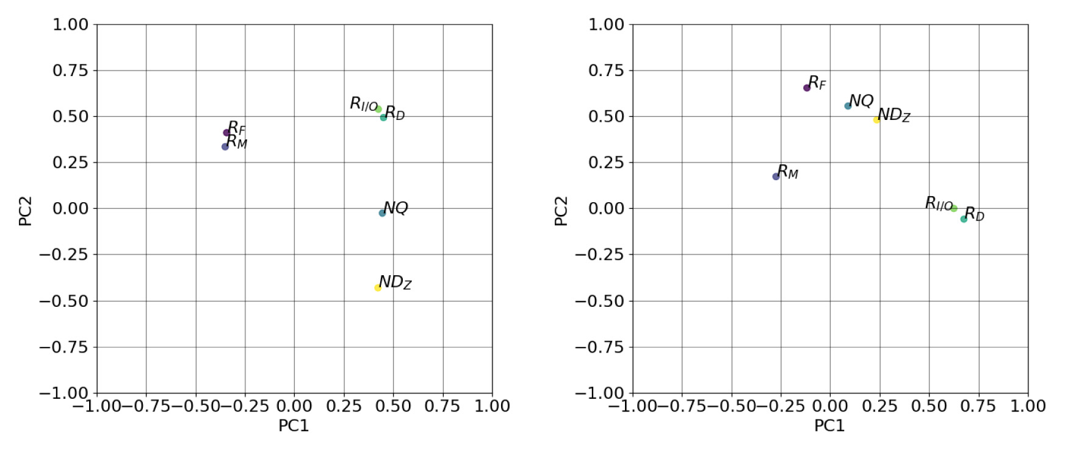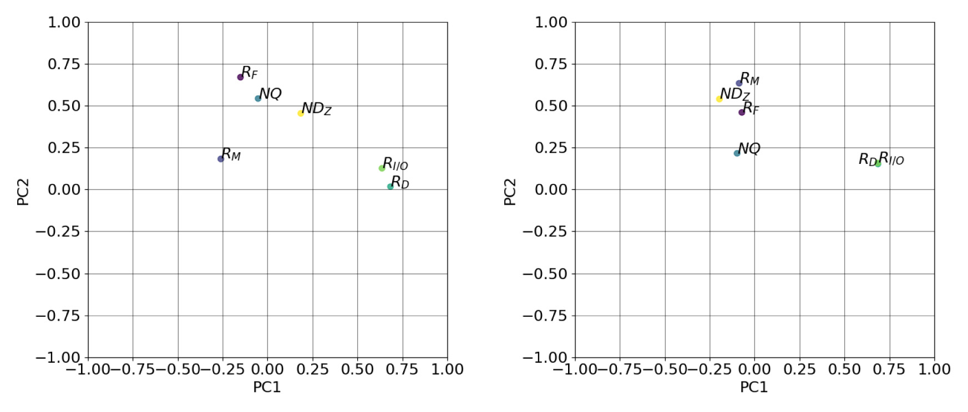

|  |  |  |  |
| --- | --- | --- | --- |
| *Y. Tsujita et al.* |  |  | *Array 15 (2022) 100179* |

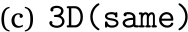 

**Fig. 14.** Factor loading of the metrics used relative to PC1 and PC2.

operations and electric power, another solution for power management is monitoring I/O activities in HPC jobs and characterizing those jobs based on their I/O intensity. Numerous studies have focused on log analysis as a way to reveal the I/O activities of HPC jobs [26–28]. For example, Liu et al. [26] developed an application characterization analysis framework that included I/O activities and successfully incor-porated consideration for I/O activities in job scheduling. Separately, Wang et al. [27] proposed a multilateral framework to investigate I/O activities and the root causes of I/O problems, from a comprehensive analysis of large-scale I/O log data, in which Darshan [29,30] was introduced to collect I/O performance metrics. Lockwood et al. [28] proposed a holistic analysis framework for use in investigating whole HPC systems using numerous analysis and monitoring tools such as Darshan. However, the abovementioned studies did not discuss electric power issues, even though there have been studies that discussed power management from the viewpoint of I/O activities [31,32]. For example, Manousakis et al. [31] proposed a framework that can be used to mini-mize electric power in I/O-intensive jobs, and Lee et al. [32] addressed providing a framework that can be used to supply more electric power to compute-intensive jobs using I/O aware power shifting algorithms. Similar to these research efforts, we focused on using several I/O activity metrics to classify HPC jobs in terms of electric power and have observed some specific features of I/O-intensive HPC jobs, such as node-layout specifications or required disk space allocations, through correlation studies of those metrics. Through the Fugaku operation, we have faced I/O contentions among jobs. Fugaku has different system

14

*Y. Tsujita et al.*  *Array 15 (2022) 100179*

prediction. However, in our work, which is focused on electric power consumption using ML classification models with metrics recorded in job stats log data, we found that correlation studies can produce rela-tively strong positive associations between the utilization ratios of CPUs and memory devices and electric power levels per node. Additionally, correlation studies between disk utilization ratios and electric power levels per node showed strong negative associations in a fixed 3D node-layout case because I/O-intensive jobs were frequently executed in that node-layout. Based on these results, we applied an ML-based approach to classifying jobs in terms of electric power levels per node. The major factors used to predict electric power levels are the utilization ratios of CPUs and memory devices, but additional metrics such as the disk utilization ratio have also improved the precision of the predicted classification models. Finding preferable metrics through correlation analysis and automatic selection of prediction models applied in [35] is a process worth being introduced into our ML scheme.

One of the remaining that will be discussed in this paper is the method used to evaluate predicted classification models for imbalanced datasets in ML studies. In this context, He and Garcia reported im-proved precision–recall curve efficiency, even in imbalanced datasets in their paper [38] in which they clearly discussed the problems that occurred in those datasets along with some state-of-the-art solutions for those problems. Separately, Jauk et al. produced a survey paper in which they discussed state-of-the-the-art studies about failure pre-diction in many leading HPC systems [39]. Although they discussed effective evaluations among different classification models in reference to imbalanced datasets, they only touched briefly on studies that paid close attention to the problem, despite the large number of research papers surveyed. Additionally, they limited their remarks to stating that no numerical or statistical analysis studies have yet been conducted to address this problem. Contrastingly, in our research, we proposed a combined evaluation score by introducing F1-score, PR-AUC, and MCC for use in comparisons among different classification models using imbalanced datasets. Although our proposal works acceptably in our ML study using K computer log data, it will be necessary to propose an improved or optimum method of conducting ML-based evaluations of imbalanced datasets in the future.

**6. Conclusions**

Herein we reported the analysis of two years of job stats log data collected from the K computer to classify HPC jobs in terms of electric power levels per compute node. This study is part of efforts to facilitate future advanced power-aware compute node allocation in accordance with effective job scheduling in Fugaku, which is the successor of the K computer. Our results showed that we need the ability to perform more suitable compute node allocations in order to manage power consump-tion within controllable conditions and to ensure stable operations in such situations.

Based on the above, we studied classification methodology in terms of electric power consumed by compute nodes through correlation coefficient analysis and ML-based classification using associated metrics in job stat log data and determined that there were relatively strong correlations between electric power and CPU and memory bandwidth utilization ratios. Additionally, there were relatively strong negative correlations between metrics related to file I/O and electric power in the node-layout in which I/O-intensive jobs were most frequently executed. Based on this correlation study, we examined four classifi-cation models provided from *scikit-learn* and discovered some specific results related to allocated compute node-layouts. For example, we established the overall score ranging from 0 to 1 to evaluated predicted classification models using F1-score, PR-AUC, and MCC, which are tolerant measures even in imbalanced datasets. Through that exam-ination, we found that the RFC model achieved the highest overall score (0.98) using only CPU and memory bandwidth utilization ratios when classifying at 60 W in the maximum electric power per node.

15

*Y. Tsujita et al.*  *Array 15 (2022) 100179*

**References**

[1] The supercomputer Fugaku [cited 2022-04-26]. [link]. URL [https://www.r-ccs.](https://www.r-ccs.riken.jp/en/fugaku/)  [riken.jp/en/fugaku/](https://www.r-ccs.riken.jp/en/fugaku/).

[2] [Akimoto H, Okamot](https://www.r-ccs.riken.jp/en/fugaku/)o T, Kagami T, Seki K, Sakai K, Imade H, Shinohara M, Sumi-moto S. File system and power management enhanced for supercomputer Fugaku.

Fujitsu Tech Rev 2020;(3). [cited 2022-04-26]. URL [https://www.fujitsu.com/ global/about/resources/publications/technicalreview/2020-03/article05.html.](https://www.fujitsu.com/global/about/resources/publications/technicalreview/2020-03/article05.html)

[3] [Uno](https://www.fujitsu.com/global/about/resources/publications/technicalreview/2020-03/article05.html)  [A,](https://www.fujitsu.com/global/about/resources/publications/technicalreview/2020-03/article05.html)  [Sueyasu](https://www.fujitsu.com/global/about/resources/publications/technicalreview/2020-03/article05.html)  [F,](https://www.fujitsu.com/global/about/resources/publications/technicalreview/2020-03/article05.html)  [Sekizawa](https://www.fujitsu.com/global/about/resources/publications/technicalreview/2020-03/article05.html)  [R.](https://www.fujitsu.com/global/about/resources/publications/technicalreview/2020-03/article05.html)  [Operations](https://www.fujitsu.com/global/about/resources/publications/technicalreview/2020-03/article05.html)  [management](https://www.fujitsu.com/global/about/resources/publications/technicalreview/2020-03/article05.html)  [software](https://www.fujitsu.com/global/about/resources/publications/technicalreview/2020-03/article05.html)  of supercomputer Fugaku. Fujitsu Tech Rev 2020;(3). [cited 2022-04-26]. URL [https://www.fujitsu.com/global/about/resources/publications/technicalreview/](https://www.fujitsu.com/global/about/resources/publications/technicalreview/2020-03/article10.html)  [2020-03/article10.html.](https://www.fujitsu.com/global/about/resources/publications/technicalreview/2020-03/article10.html)

[4] [Uno A, Hida H, Inoue F](https://www.fujitsu.com/global/about/resources/publications/technicalreview/2020-03/article10.html), Ikeda N, Tsukamoto T, Sueyasu F, Matsushita S, Shoji F.

Operation of the k computer focusing on system power consumption. IPSJ Trans Adv Comput Syst 2015;8(4). 13–25. (in Japanese).

[5] Tsujita Y, Uno A, Sekizawa R, Yamamoto K, Sueyasu F. Job classification through long-term log analysis towards power-aware HPC system operation. In: 2021 29th Euromicro International Conference on Parallel, Distributed and Network-Based Processing (PDP). IEEE; 2021, p. 26–34. [http://dx.doi.org/10.1109/PDP52278. 2021.00014](http://dx.doi.org/10.1109/PDP52278.2021.00014).

[6] Matthews BW. Comparison of the predicted and observed secondary structure of T4 phage lysozyme. Biochim Biophys Acta (BBA) - Protein Struct 1975;405(2). 442–451. <http://dx.doi.org/10.1016/0005-2795(75)90109-9>.

[7] Ajima Y, I[noue T, Hiramoto S, Takagi Y, Shimizu T. The Tof](http://dx.doi.org/10.1016/0005-2795(75)90109-9)u interconnect. IEEE Micro 2012;32(1). 21–31. <http://dx.doi.org/10.1109/MM.2011.98>.

[8] Sakai K, Sumimoto S, Kur[okawa M. High-performance and highl](http://dx.doi.org/10.1109/MM.2011.98)y reliable file system for the K computer. Fujitsu Sci Tech J 2012;48(3). 302–309.

[9] Hirai K, Iguchi Y, Uno A, Kurokawa M. Operations management software for the K computer. Fujitsu Sci Tech J 2012;48(3). 310–316.

[10] Sumimoto S. An overview of Fujitsu’s Lustre based file system. In: Lustre User Group 2011. 2011.

[11] Yamamoto K, Tsujita Y, Uno A. Classifying jobs and predicting applications in HPC systems. In: High Performance Computing - 33rd International Conference, ISC High Performance 2018, Frankfurt, Germany, June 24-28, 2018, Proceedings. Lecture Notes in Computer Science, vol. 10876, Springer; 2018, p. 81–99.

[12] Redash [cited 2022-04-26]. [link]. URL <https://redash.io/>.

[13] SciPy [cited 2022-04-26]. [link]. URL [ht](https://scipy.org/)[tps://scipy.org/.](https://redash.io/)

[14] You H, Zhang H. Comprehensive wor[kload analysis an](https://scipy.org/)d modeling of a petas-cale supercomputer. In: Job Scheduling Strategies for Parallel Processing, 16th International Workshop, JSSPP 2012, Shanghai, China, May 25, 2012. Revised Selected Papers. Lecture Notes in Computer Science, vol. 7698, Springer; 2012, p. 253–271. <http://dx.doi.org/10.1007/978-3-642-35867-8_14>.

[15] Dutot P, Geo[rgiou Y, Glesser D, Lefevre L, Poquet M, Rais I](http://dx.doi.org/10.1007/978-3-642-35867-8_14). Towards energy budget control in HPC. In: 17th IEEE/ACM International Symposium on Cluster, Cloud and Grid Computing (CCGRID). IEEE Press; 2017, p. 381–390. [http: //dx.doi.org/10.1109/CCGRID.2017.16](http://dx.doi.org/10.1109/CCGRID.2017.16).

[16] [Rajagopal D, Tafani D, Georgiou Y, Gl](http://dx.doi.org/10.1109/CCGRID.2017.16)esser D, Ott M. A novel approach for job scheduling optimizations under power cap for ARM and Intel HPC systems. In: 24th IEEE International Conference on High Performance Computing (HiPC).

IEEE Computer Society; 2017, p. 142–151. [http://dx.doi.org/10.1109/HiPC. 2017.00025](http://dx.doi.org/10.1109/HiPC.2017.00025).

[17] Saillant T, Weill J-C, Mougeot M. Predicting job power consumption based on RJMS submission data in HPC systems. In: High Performance Computing - 35th Iternational Conference, ISC High Performance 2020, Frankfurt/Main, Germany, June 22–25, 2020, proceedings. Lecture Notes in Computer Science, vol. 12151, Springer; 2020, p. 63–82. <http://dx.doi.org/10.1007/978-3-030-50743-5_4>.

[18] Pedregosa F, Varoquaux G, [Gramfort A, Michel V, Thirion B, Grisel O, Blond](http://dx.doi.org/10.1007/978-3-030-50743-5_4)el M, Prettenhofer P, Weiss R, Dubourg V, Vanderplas J, Passos A, Cournapeau D, Brucher M, Perrot M, Duchesnay É. Scikit-learn: Machine learning in Python.

J Mach Learn Res 2011;12(85). 2825–2830. [cited 2022-04-26]. URL [https: //jmlr.org/papers/v12/pedregosa11a.html](https://jmlr.org/papers/v12/pedregosa11a.html).

[19] [Scikit-learn](https://jmlr.org/papers/v12/pedregosa11a.html)  [[cited](https://jmlr.org/papers/v12/pedregosa11a.html)  [2022-04-26].](https://jmlr.org/papers/v12/pedregosa11a.html)  [[link].](https://jmlr.org/papers/v12/pedregosa11a.html)  URL [https://scikit-learn.org/stable/](https://scikit-learn.org/stable/modules/grid_search.html)  [modules/grid_search.html](https://scikit-learn.org/stable/modules/grid_search.html).

[20] [Saito T, Rehmsmeier M.](https://scikit-learn.org/stable/modules/grid_search.html) The precision-recall plot is more informative than the ROC plot when evaluating binary classifiers on imbalanced datasets. PLoS ONE 2015;10(3). 1–21. <http://dx.doi.org/10.1371/journal.pone.0118432>.

16